

**Name: Chandana Ramesh Galgali**

**Batch: B-1 Roll No.:16010422234**

**Experiment No.:1**

**Aim**: Understanding of the Data

___________________________________________________________________________

**Resources needed:** Any RDBMS, EXCEL, Data storage tool

___________________________________________________________________________

**Theory:**

In order to make data ready for data mining process, data exploration is essential step to develop a high-level understanding of the data. Data exploration includes in detail analysis of attributes and their data values and visualization. It aimed at identifying possible relationship between two or more variables/objects.

Broadly classifying, there are two types of attributes, numeric and categorical.

**Categorical Attribute:**

In categorical, each value represents some kind of category, code, or state. Categorical variables are either nominal or ordinal, depending on the extent of information the numerical coding provides.

The values of a nominal attribute are symbols or names of things. Nominal means “relating to names.”

E.g. hair color and occupation are two attributes describing person objects.

Possible values for hair color are black, brown, blond, red, auburn, gray, and white. For occupation, possible values are teacher, dentist, programmer, farmer etc.

An ordinal attribute is an attribute with possible values that have a meaningful order or ranking among them, but the magnitude between successive values is not known. For example, grade attribute with values A+, A,A-, B, C; Student_progress attribute with values Good, average , poor. The central tendency of an ordinal attribute can be represented by its mode and its median (the middle value in an ordered sequence), but the mean cannot be defined.

Nominal, binary, and ordinal attributes are qualitative. That is, they describe a feature of an object without giving an actual size or quantity. The values of such qualitative attributes are typically words representing categories.

**Numeric Attributes:**

A numeric attribute is quantitative; that is, it is a measurable quantity, represented in integer or real values. Numeric attributes can be interval-scaled or ratio-scaled.

*Interval-Scaled Attributes:*

Interval-scaled attributes are measured on a scale of equal-size units. The values of interval-scaled attributes have order and can be positive, 0, or negative. Thus, in addition to providing a ranking of values, such attributes allow us to compare and quantify the difference between values.

For example, temperature, humidity attributes

*Ratio-Scaled Attributes:*

A ratio-scaled attribute is a numeric attribute with an inherent zero-point. That is, if a measurement is ratio-scaled, we can speak of a value as being a multiple (or ratio) of another value. In addition, the values are ordered, and we can also compute the difference between values, as well as the mean, median, and mode.

For example, *years of experience*

___________________________________________________________________________

**Procedure / Approach /Algorithm / Activity Diagram:**

1. Download the large dataset for the purpose of exploration and ensure that dataset has variety of attributes; number of attributes must be at least 25.
2. Identify the category of each attribute from the dataset which you have created.
3. Identify the attributes which can provide any kind of useful information either collectively or as an individual. Also, discuss the about the information provided by the attribute and how it will be computed?

___________________________________________________________________________

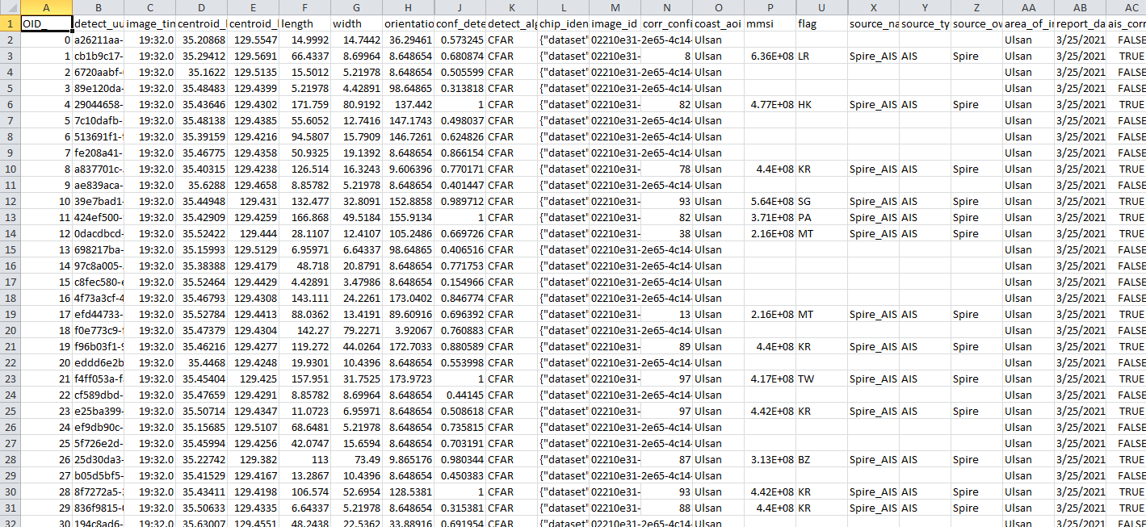

**Results: (Program printout with output / Document printout as per the format)**

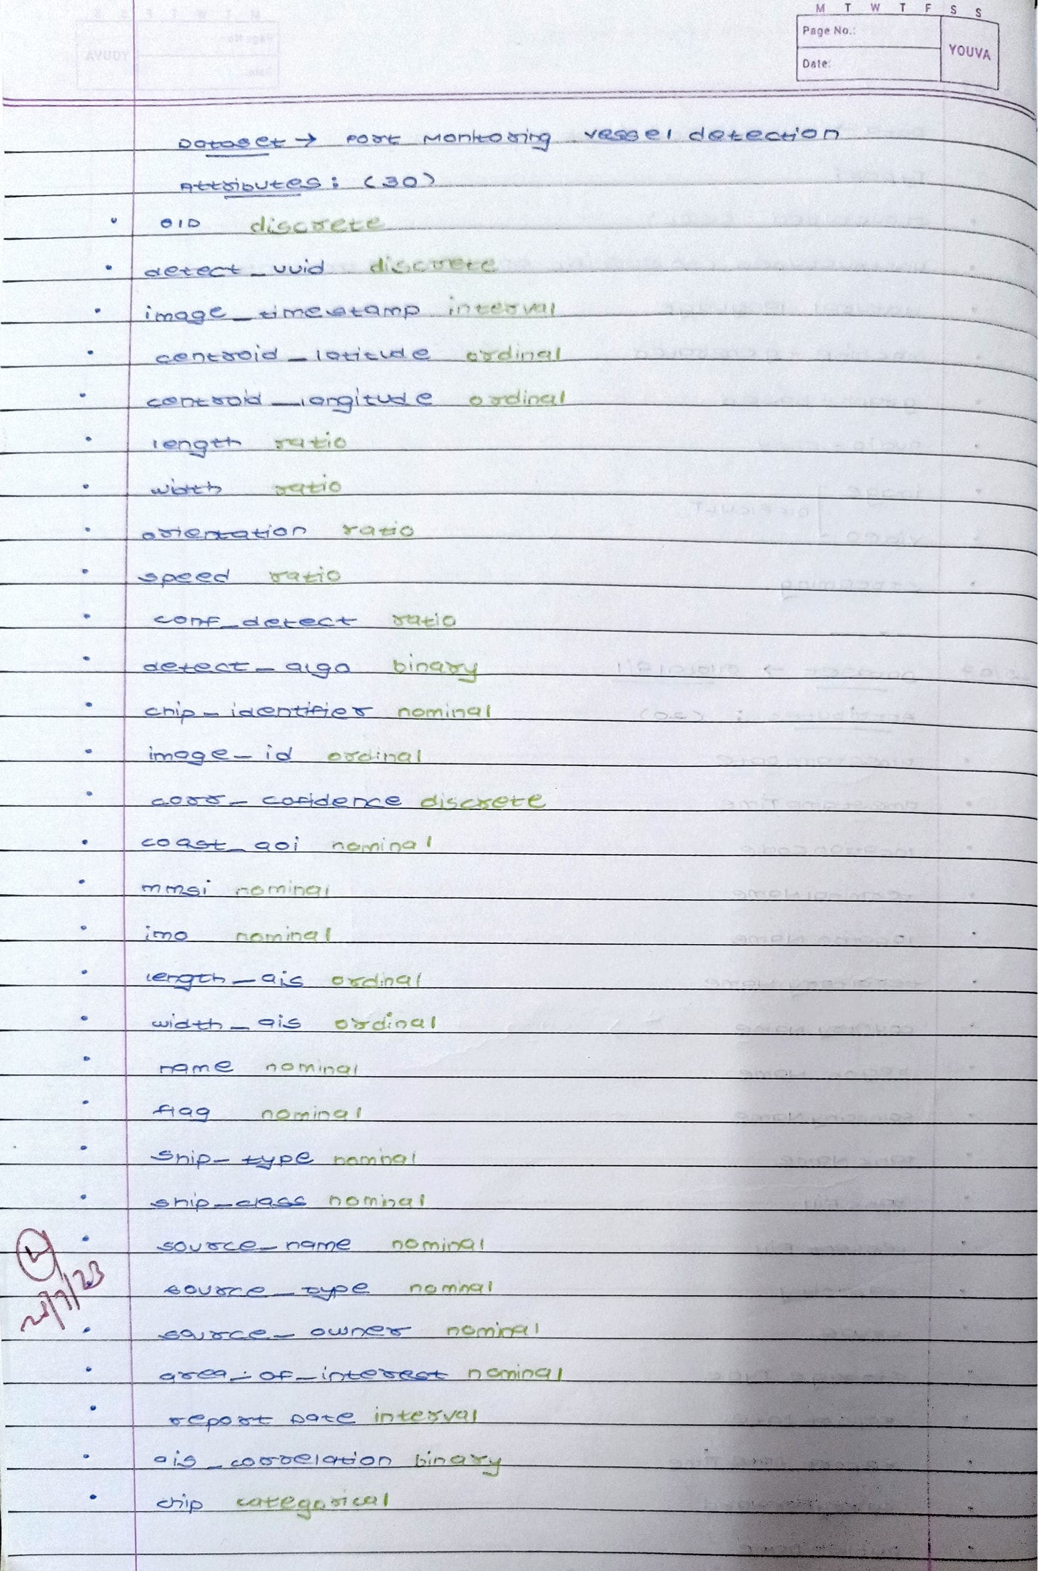

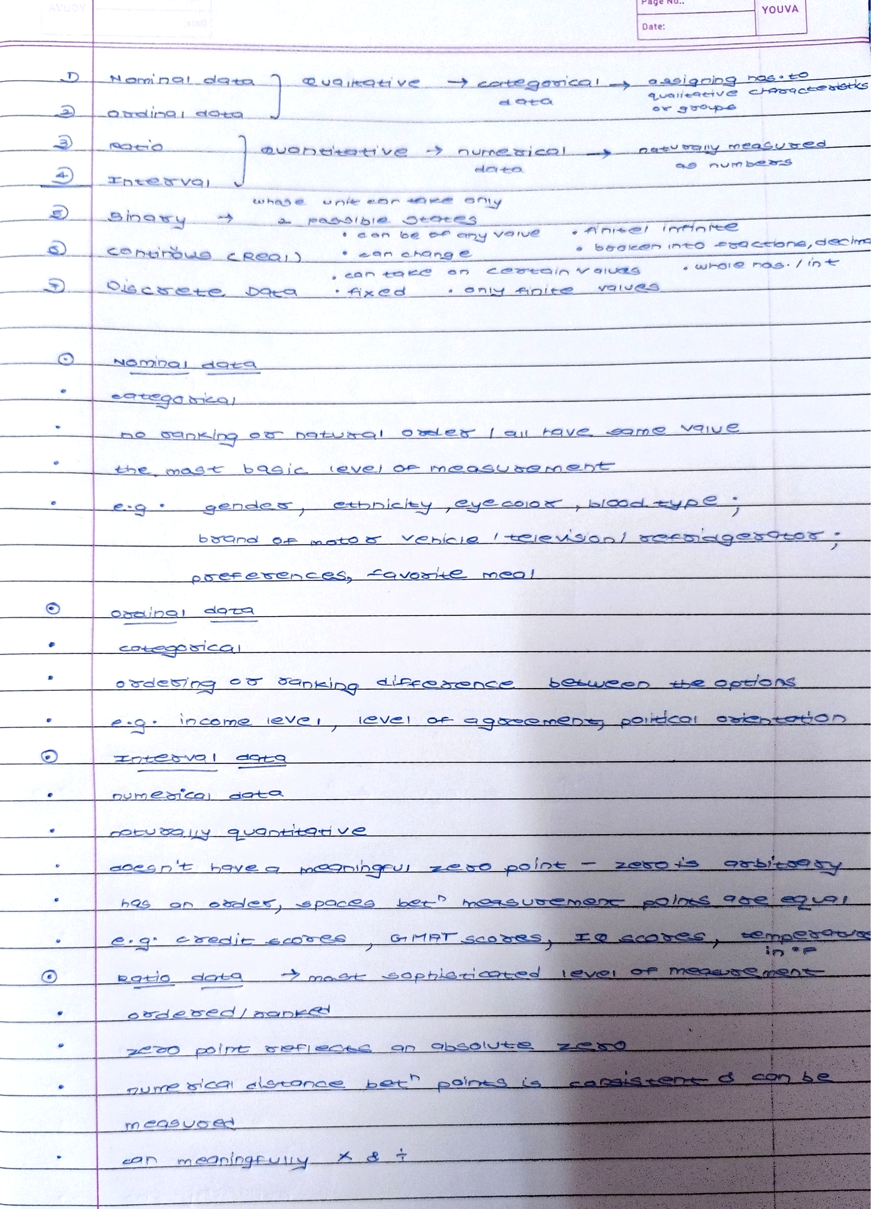___________________________________________________________________________

**Questions:**

1. Compare Discrete and Continuous Attributes. Give at least 5 examples of each.

Ans: Discrete and continuous attributes are two types of variables used in statistics and data analysis. Here are the definitions and examples of each:

Discrete Attributes:

*Gender*: This attribute can take on only a limited number of values, such as "male" or "female."

*Marital Status*: This attribute can have discrete values like "single," "married," or "divorced."

*Eye Color*: This attribute can have values like "blue," "brown," "green," etc.

*Number of Children*: This attribute represents the count of children a person has, which can only be a whole number.

*Education Level*: This attribute can have discrete values like "high school," "bachelor's degree," "master's degree," etc.

Continuous Attributes:

*Height*: This attribute can take on any value within a range, such as 5.6 feet, 6.2 feet, etc.

*Weight*: This attribute can have any value within a range, such as 150 lbs, 180 lbs, etc.

*Temperature*: This attribute can have any value within a range, such as 25.5°C, 30.2°C, etc.

*Income*: This attribute represents a person's income and can have any value within a range, such as $50,000, $75,000, etc.

*Time*: This attribute can have any value within a range, such as 10:30 AM, 2:45 PM, etc.

Discrete attributes have a limited number of distinct values, while continuous attributes can take on any value within a range.

1. What are the different jobs associated with Data Analysis? What are the qualities and features needed to do these jobs in an individual?

Ans: There are various job roles associated with data analysis, each with its own specific responsibilities and requirements. Here are some common data analysis job roles along with the qualities and features needed to excel in these positions:

Data Analyst:

*Qualities*: Strong analytical skills, attention to detail, problem-solving abilities, and proficiency in statistical analysis.

*Features*: Proficiency in data manipulation and analysis tools (e.g., SQL, Excel, Python, R), ability to interpret and present data insights effectively, and a solid understanding of data visualization techniques.

Business Analyst:

*Qualities*: Strong business acumen, excellent communication skills, ability to understand and translate business requirements into data-driven solutions.

*Features*: Proficiency in data analysis tools, knowledge of business intelligence platforms, familiarity with data modeling and database concepts, and the ability to collaborate with stakeholders from different departments.

Data Scientist:

*Qualities*: Strong mathematical and statistical skills, expertise in machine learning algorithms, programming proficiency, and the ability to think critically and creatively.

*Features*: Proficiency in programming languages (e.g., Python, R), knowledge of advanced statistical techniques, experience with big data technologies, and the ability to develop predictive models and algorithms.

Data Engineer:

*Qualities*: Strong programming skills, knowledge of database systems, data architecture expertise, and problem-solving abilities.

*Features*: Proficiency in programming languages (e.g., Python, SQL), experience with database technologies (e.g., SQL, NoSQL), familiarity with data integration and ETL (Extract, Transform, Load) processes, and the ability to design and optimize data pipelines.

Data Visualization Specialist:

*Qualities*: Creativity, attention to detail, strong design skills, and the ability to transform complex data into visually appealing and understandable visualizations.

*Features*: Proficiency in data visualization tools (e.g., Tableau, Power BI), knowledge of design principles and best practices, understanding of user experience (UX) design, and the ability to tell compelling stories through data visualizations.

In addition to these specific qualities and features, individuals in data analysis roles should also possess a curious and inquisitive mindset, a passion for continuous learning, and the ability to work effectively in a team environment. Strong communication and presentation skills are also crucial for effectively conveying insights and recommendations derived from data analysis.

___________________________________________________________________________

**Outcomes:**

Understanding of the Data

___________________________________________________________________________

**Conclusion: (Conclusion to be based on the objectives and outcomes achieved)**

The experiment provided a solid foundation in working with categorical and numerical attributes. We gained practical skills and knowledge that can be applied in various data analysis tasks, such as exploratory data analysis. Understanding the characteristics and nuances of different attribute types is crucial for extracting meaningful insights and making informed decisions in data science and analytics.

**Grade: AA / AB / BB / BC / CC / CD /DD**

Signature of faculty in-charge with date

___________________________________________________________________________

**References:**

Books/ Journals/ Websites:

1. Han, Kamber, "Data Mining Concepts and Techniques", Morgan Kaufmann 3nd Edition